# Introduction

* 1. History of fish tagging/biologging
     1. Different telemetry methods
     2. Acoustic telemetry
     3. Acoustic data storage tags
        1. Geolocation modelling
           1. Method: HMM with observation and behavioural model
           2. Different techniques for behavioural states

Spectral method by Heerah 2017

Tidal method by Pedersen 2008

Drawbacks of the methods for species with limited knowledge, a benthic lifestyle with a broad range of horizontal movement

* 1. The starry smooth-hound shark
     1. Morphology:
        1. Ventral snout: perfect for feeding on animals on seafloor
           1. All time spent swimming above seafloor
     2. Ecology
        1. Life history
           1. Feeding: crustaceans, swimming shorewards at night
        2. Migration
           1. Sex bias: Males into Northern North Sea, females into Bay of Biscay
           2. Daily horizontal distance: up to 70km
        3. Reproduction
           1. Aplacentary viviparous, unlike M. mustelus but e.g. like M. antarcticus
           2. Different life stages of young
           3. Multiple paternity, sperm storage up to a year
     3. Research gaps
        1. Migration: sex bias known, but no exact locations, timing also unknown
           1. Horizontal and vertical behaviour during migration
           2. Until now, many capture/recapture studies, but no in-depth tracking studies (to our knowledge)
        2. Reproduction: reproductive habitats already studied to some extent, but e.g. parturition site Western Scheldt unconfirmed
           1. General details about parturition: all pups released at once, batches?
     4. Abundance
  2. Communication of fish movement ecology studies
     1. Problem: the data is complex and difficult to understand for non-experts, yet it is imperative to communicate the scientific results to transform them into action/change
     2. The quadruple helix
        1. Communication from (fish) scientists to politicians to inform political and fishery management decisions
        2. Creating awareness within the general public
        3. Information of industry stakeholders, e.g. wind farm companies
  3. Aims of the work
     1. Characterizing the vertical behaviour (i.e. the depthlogs) of the migrating sharks
        1. Motivation: provide additional input for geolocation models
           1. Behavioural switches!

Implement unsupervised learning aka k means clustering to infer behavioural states/switches = test a new way of inferring behavioural states

Working hypothesis: Using k-means on summary statistics and their wavelet analysis results successfully identifies putative migration periods, as identified by visual analysis of the raw depthlog

* + 1. Exploratory and descriptive analysis of the female sharks’ vertical behaviour in the Western Scheldt using the acoustic detections data
       1. Sub-dataset of July 2019 since this has the highest density of acoustic detections (~6000 out of ~10000 total detections)
       2. Working hypothesis: Sharks predominantly use the seafloor section of the space around a receiver (predominantly = xx%, or result of chi2?)
       3. Working hypotheses about the acoustic dataset in general:
          1. the seasonal presence of M. asterias is reflected in the acoustic detection dataset

H0 = the mean # detections per month in summer months, here: March – September significantly differs from that in winter months (t-test or Levene test)

PLOT (maybe: boxplot, winter vs summer months, detections grouped into months)

* + - * 1. the sex bias, i.e. that females are predominantly present in the WS, is reflected in the acoustic detections

H0 = number of females detected per month significantly differs from the number of males (t test)

* + 1. Converting the first results into a format that transmit relevant messages to one/several groups of non-scientists
       1. No working hypothesis, bc only concept and first draft version, but outlook: further development and then study with people about how well they understood the information provided
    2. *State that most of the analyses are descriptive/exploratory bc not much is known about the species yet and the dataset Is a bit too small to perform real statistical tests on*

# Materials and Methods

*contains the design of the research: e.g. experimental design, area description, sampling methods, analysis methods, statistical design and methods*

* 1. Study Area
     1. The BPNS
        1. Human activities
           1. Windfarms
           2. Shipwrecks
           3. Submarine power and telecommunication cables
           4. MAP: BPNS with cables, windfarms and shipwrecks,

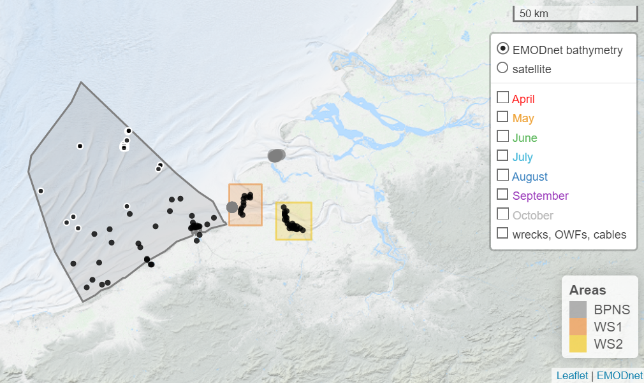

* + - * 1. Maybe 2 maps next to each other, one with acoustic receivers (+ sub areas/receiver arrays, and 2 tagging locations) and one with the human activities (bc 1 map will be too full?)
        2. Mention that for the windfarms and cables, the years are filtered to be <= 2020
      1. The Scheldt Estuary
         1. The Westerschelde

MAP: Schelde with bathymetry raster or contour lines

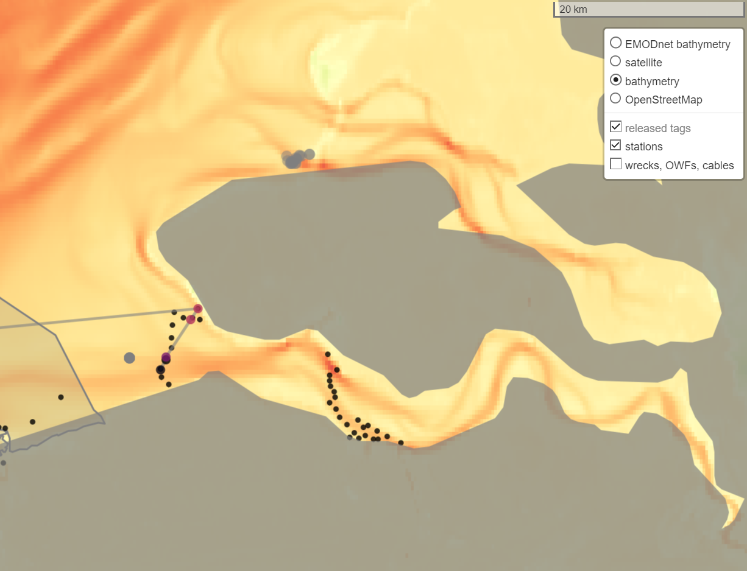

Acoustic receiver arrays in WS

Mixing

Salinity

Food abundance

Biodiversity and most prominent species

* + 1. The English channel
       1. Bathymetry
          1. *Maybe* map with bathy contour lines?
       2. Food abundance?
       3. Temperature seasonality
  1. Acoustic (receiver) Array
     1. *Find out*: how many ac. Receivers in study area?
     2. *Question*: TABLE with lat lon & names of receiver stations?

|  |  |  |
| --- | --- | --- |
| Station name | Latitude | longitude |
| BPNS-Birkenfels | 51.4 | 3.2 |

* + 1. Detection range
  1. Tags & Tagging Procedure
     1. Dates of boat trips
     2. tags technical details
     3. tagging procedure
  2. Data Analysis
     1. Acoustic Detections
        1. Descriptive analysis
           1. Omitted tags
           2. Summary statistics

# Individuals and # detections per station/array

* + - 1. Depth use analysis
         1. Bathymetry dataset
         2. Method: radius of 200m (=detection range)
    1. Data Storage Tags
       1. Summary statistics
          1. Mean/median depth, depth range, max and min depth, vert. speed
          2. Daily, weekly, monthly
       2. Migration Patterns/Long term DST/Migration Analysis
          1. Wavelet on daily summary statistics
          2. **Identified putative migration weeks:**

**Wavelet on raw depth values (? Does that make sense? To assess diel vertical behavior during migration)**

**Method: extract week of likely migration and do wavelet analysis on raw (maybe scaled?) depth data for that time: no daily summaries!**

**FFT on depth values for putative migration periods**

# Results

* 1. TABLE with info on each individuals

|  |  |  |  |  |  |  |  |  |
| --- | --- | --- | --- | --- | --- | --- | --- | --- |
| Tag_sr_nr | Tag_date | First det. | Last det. | # det | Sex | Size | Tag_loc | RI |
|  |  |  |  |  |  |  |  |  |

* 1. Acoustic Detections
     1. PLOT: Abacus plot

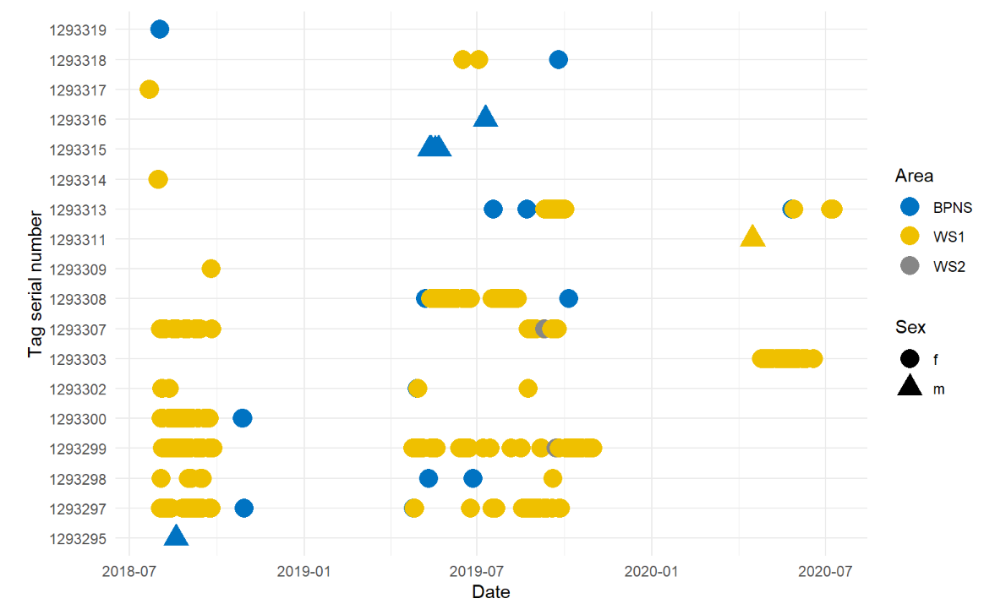

* + 1. PLOT: Detections & # of sharks tagged

Espinoza 2016, plus # detections??

* + 1. PLOT: # detected individuals, # detections (2 plots next to each other with circles)

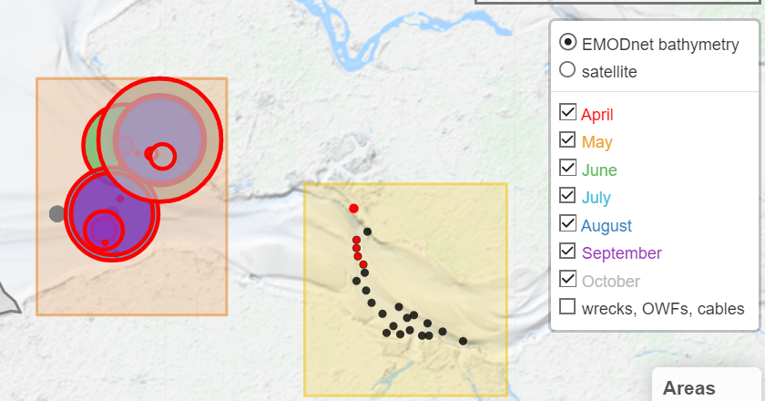

* + 1. Vertical space use analysis
    2. PLOT: depth of bathymetry vs depths of detections & depth bins
       1. Maybe: chi2 test to compare depth bins & ac. Detections?

* 1. Data storage tags
     1. How many tags got recovered
     2. Summary stats on dst data

|  |  |  |  |  |  |  |
| --- | --- | --- | --- | --- | --- | --- |
| Tag_sr_nr | # days logged | Min depth | Max depth | Median depth (?) | Max. daily hor. dist | Total hor dist |
|  |  |  |  |  |  |  |

* + 1. MAP: geolocation outputs of recovered short-term dst tags (include)

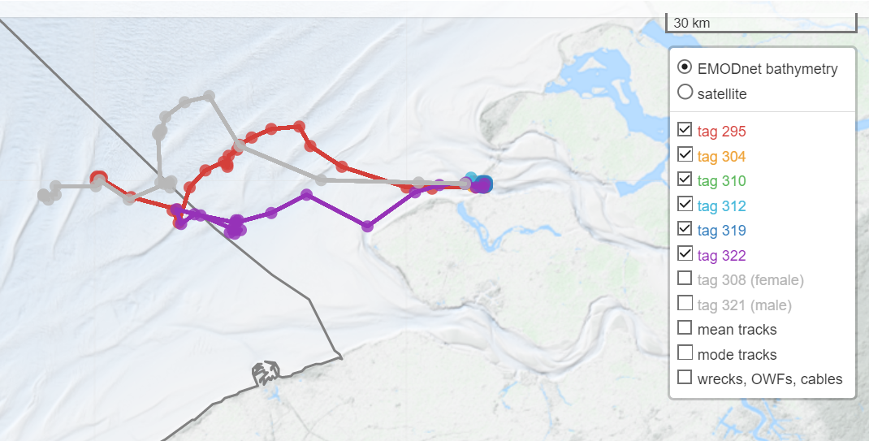maybe minimap with tag @neelte jans

* + 1. PLOT: Raw depth and temp data

* + 1. Summary Statistics
    2. Wavelet Analysis
    3. Clustering
    4. PLOT: summary stats, autocorrelation, wavelet, clustering

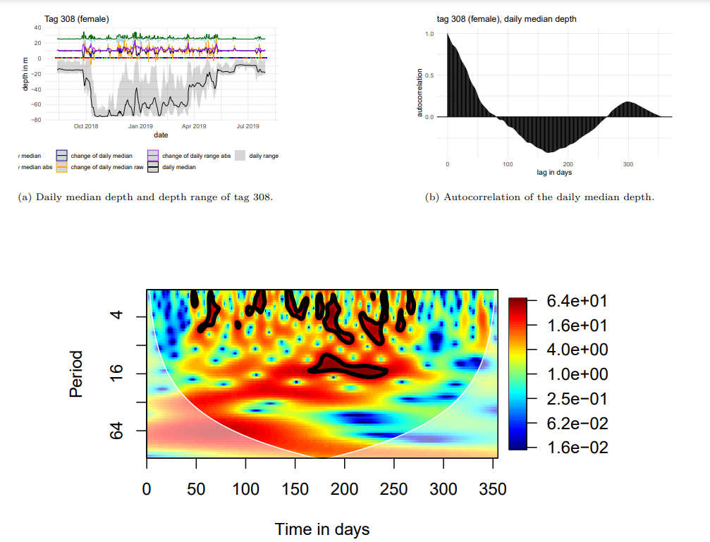

* + 1. **wavelet plot and frequency spectrum of putative migration period raw depthlogs**

# Discussion

*Discuss working hypotheses,* critical analysis of the interpretation of the data, compared to the available literature

* 1. Seasonality of starry smooth-hound presence in/around westerschelde, according to ac. detections
     1. Highly seasonal (only in summer)
     2. Sex-biased (mostly females)
     3. Possible pupping area, but this dataset not sufficient to confirm
  2. Recovering tags
     1. Possible death reasons of short term dst’s
        1. Tagging consequences
           1. High sensitivity (verhelst, pers. Comm.)
        2. Not likely: death bc of seals (no temp increase)
        3. Laying dead on seafloor (tidal signal)
  3. Ecological inferences from migration dataset analysis
     1. Vertical patterns during migration
        1. Yes, but eventually swimming inshore
        2. How strong are diel patterns in putative migration weeks? Check wavelet median depth
  4. Limits of biologging/ fish tagging
     1. Geolocation modelling already leads to impressive results for comparatively well-studied species (e.g. cod (?), sea bass), but still limited in accuracy for not wellknown species
     2. Limits of geolocation modelling
        1. Resolution of bathymetry dataset
           1. Possible that shark was in certain area but bc bathymetry grid = summary (e.g. mean), geolocation model rules this location out (cf Woillez 2016)
        2. Behaviour incorrectly/not inferred
           1. E.g. active vs inactive behaviour:
     3. Fish tagging
        1. It’s kind of the best we can do today, but non-satellite tagging methodologies have huge drawbacks still
        2. Acoustic telemetry: high resolution on regional scale (i.e. where the receivers are placed) but outside of receiver networks: no knowledge at all
  5. Limits of the chosen analysis methods
     1. Wavelet analysis: no super fine scale analysis possible bc of limited res in both time and freq domain
  6. Limits of the acoustic detection dataset
     1. There are ~10 000 detections within ~2 yrs but compared to other studies (ref to other studies!) this is not that much.
     2. Plus, the horiz resolution of receivers, esp in/around the WS is not good bc rather receiver gate than array to monitor species swimming into/out of the Scheldt river (= different use case scenario: receiver array needed to resolve locations of sharks better, and to e.g. enable triangulation)
  7. Limits of the data storage tag dataset
     1. Female shark: deeper than tag depth limit (68m): geolocation model inaccurate, shark putatively went into the Hurd deep (MRGID: 3321) in English channel
     2. Only one individual per sex: not reliable, no statistics possible

# Conclusion

*a brief summary of the main findings (original data, lesson learned,…)*

1. Possible improvements of tagging procedure (correct place here?)

# Outlook

*Alle kapitel aus der Einleitung wieder aufnehmen*

1. Acoustic detections additional analyses
   1. Vertical space use: resolve individuals to see if there are differences between ind. Sharks
2. Improvements of geolocation model for M. asterias
   1. Boundary condition: max depth of fish per day == max depth of bathy for that day
   2. Behavioural switch: migration/non-migration or migration/winter resident/summer resident
3. Information tool: make into interactive application (RShiny) and do tests with some of the target groups to understand how well the information is taken in

# Acknowledgements

*funding agencies, field workers*

*Question: Who provided the money for the tags? What project was that under?*

# Availability of data and materials

# References

# Annex

*All the raw data have to be added in annex*

1. Acoustic detections
2. DST datasets
   1. FFT plots for all tags
   2. Wavelet plots for all (in the k means clustering included) summary statistics

FORMULATE RESEARCH QUESTIONS!!!

# to do:

Plots & Maps

* Find out how to draw bathy contour lines in leaflet()
* Make 2nd bibliography with e.g. pers. Comm or technical reports
  + PJV pers comm. Tagging sensitivity
  + NB pers comm evtl shark only swimming at bottom
* 2nd y axis for the daily summary statistics plot (Not necessary anymore)
* Make wavelet plots for sgolay filtered median, max, min and range (DONE)
* Make map with geolocation output from jolien for intro
* Depth colour scale for bathymetry
* Figure out how to cross reference the maps (DONE)
* Make minimap in overview map another tile (only bw), to increase visibility
* Make colour scheme for the thesis
* Make the axis ticks for the raw dst plots like from the abacus plots (bimonthly breaks and monthly minor breaks)
* Highlight min, max and nullstellen in autocorrelation plot
* Nochmal die spectral method von Heerah 2017 ausprobieren (fuer diskussionen auf konferenz)

Other:

* Think about making diagrams, charts to visualize complex ideas (cf <https://twitter.com/acagamic/status/1645824832095780869>)
* Potentially center and normalize data before FFT and CWT
* Half space between value and unit
* Check what’s wrong here: 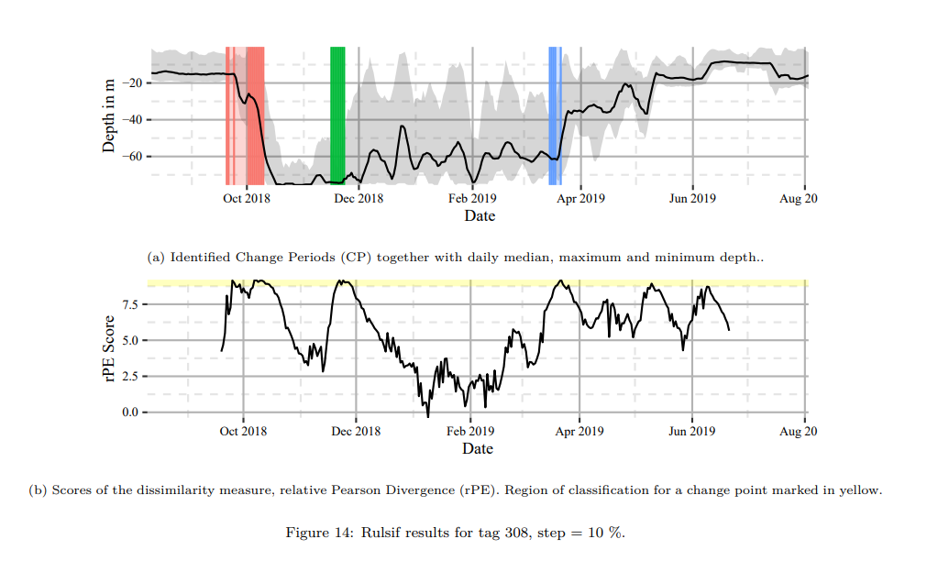the migration periods an the threshold don’t add up

Referencing and citing

* Write small function for referencing URLs (input: author, url, access date)
* Reference all used R packages
* Find out how to make second bibliography
* Find out how to do half a vertical space between value and unit (e.g. 34\,m)

Questions:

* Do you reference result items within the m&m part?